Bugs Pay for Days of Steady Reservoir Releases to Reduce Hydropeaking-Ecosystem Conflict
Short title: Reduce Hydropeaking-Ecosystem Conflict
M. Rind*, and D. E. Rosenberg *.
Author full names and affiliations.
Moazzam Ali Rind (moazzam.rind@wsu.edu)
*Department of Civil and Environmental Engineering, Utah State University, Logan, UT, USA.
David E. Rosenberg (david.rosenberg@usu.edu)
*Department of Civil and Environmental Engineering, Utah State University, Logan, UT, USA.
Corresponding author.
David Rosenberg
Email: david.rosenberg@usu.edu and Phone: +1 435-797-8689
Abstract
Steady low reservoir releases increase downstream primary and aquatic invertebrate (bugs) production. These releases also reduce hydropeaking value, raise costs for hydropower customers, and reduce funds to maintain infrastructure and repay loans. This study quantifies the win-lose tradeoff between hydropeaking value and days per month of steady low releases at Glen Canyon Dam, Arizona. We estimate win-lose tradeoffs for monthly release volumes of 0.72 to 0.94 million acre-feet from March to October 2018 and 0 to 31 days. Conservative estimates indicate that steady low releases on eight weekend days per summer month in 2018 reduced monthly hydropeaking value by $0.7 to $1.1 million. We used results to design a financial instrument that gives ecosystem managers a budget to choose days of steady low releases and pay hydropower producers for lost value. One option to reduce costs is shifting days of steady low releases in July or August to spring/fall months. Next steps include discussing the proposed instrument with more U.S. Federal agencies, conducting more flow experiments, and monitoring how timing and more steady low flow days per month affect bug production. Managers may extend to other experimental releases that mobilize sediment, build sand bars, or disadvantage non-native fish.
Keywords
Aquatic invertebrates; Hydropower generation; Multi-objective optimization; Trade-off analysis.
Graphical Abstract
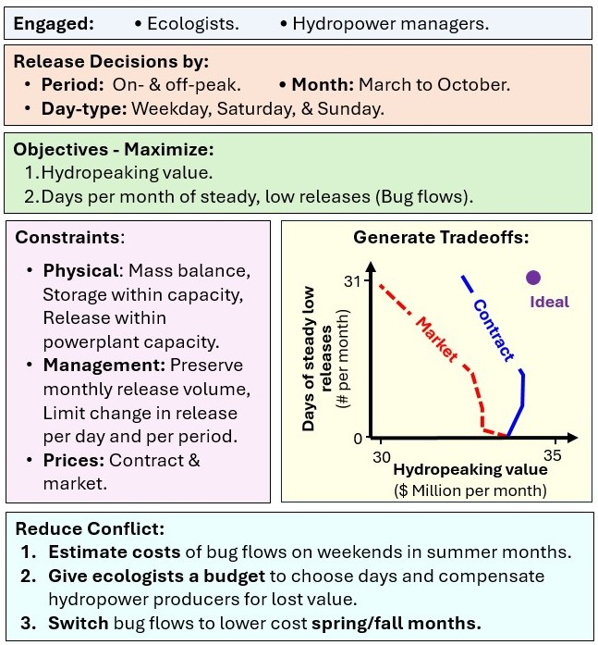
Highlights
- Steady low reservoir releases increase primary and aquatic bug production, decrease hydropeaking value, and lower funds to maintain infrastructure (win-lose conflict).
- Federal and state agencies can give ecosystem managers a budget to choose the number and timing of steady low releases and pay hydropower producers for lost value (win-win scenario).
- One promising new experiment is shifting steady low releases in July and August to spring/fall months.

Introduction
Hydropeaking operations ramp up reservoir releases during the daytime and reduce nighttime releases to follow energy demands, increase hydropower value, and meet customer contracts. These operations also disadvantage downstream ecosystems (Bunn and Arthington, 2002; Liermann et al., 2012; Moog, 1993; Poff et al., 2007; Poff and Zimmerman, 2010; Vörösmarty et al., 2010; Winemiller et al., 2016). Researchers are challenged to quantify hydropower-ecosystem tradeoffs, transform win-lose tradeoffs into wins, and help reduce conflict.
Multi-objective optimization methods are well established to quantify water supply, hydropower, ecosystem, and other tradeoffs (Porse et al., 2015; Wheeler et al., 2018; Wild et al., 2019). Numerous methods and metrics exist to estimate ecosystem impacts (Alafifi and Rosenberg, 2020; Chen and Olden, 2017; Hauer et al., 2018; Horne et al., 2016; Kraft et al., 2019; Rheinheimer et al., 2015). Jager and Smith (2008) suggest segmenting release regimes into different time periods at the annual, seasonal, or daily scale to benefit hydropower and ecosystem objectives. Daily hydropeaking creates distinct periods of high and low flow. This differentiation disadvantages taxa such as aquatic invertebrates that can only tolerate a narrow range of abiotic conditions. For example, Kennedy et al., (2016) identified a strong negative correlation between hydropeaking operations and insect (bug) diversity below Glen Canyon Dam, Arizona, and 15 other large reservoirs across the western U.S.
Several factors affect the ability to turn win-lose tradeoffs into wins. First, it is harder to find wins as the number of objectives increases (Hegwood et al., 2022). Tradeoffs are also more difficult to visualize as the number of objectives increases (Bonham et al., 2022; Rosenberg, 2015). Second, regions along concave tradeoff curves with maximum curvature or bulges (knee points) may identify promising areas for compromise (Null et al., 2021). Third, the degree of collaboration between researchers and system managers affects actionability. For example, Horne et al., (2016) found low implementation in their review of 42 ecosystem optimization studies because researchers did not follow the best practices of participatory modeling (Langsdale et al., 2013; Voinov et al., 2016). Fourth, physical and environmental systems are challenging to model, and managers rely on their experience rather than prescriptive solutions from optimization models (Horne et al., 2016). Fifth, successful implementation requires experimentation in concert with political and legislative support (Owusu et al., 2022). Hydropower-ecosystem conflicts are also more than numbers. Conflicts consume managers’ time and increase their work stress and anxiety (Unterhitzenberger et al., 2021).
This paper has goals to reduce a hydropeaking-ecosystem conflict by a) quantifying tradeoffs, b) developing a financial tool that gives ecologists more flexibility to schedule days of steady low flows that advantage bugs (bug flows), c) paying hydropower producers for lost value, and d) using the financial tool to suggest new experimental steady low flows to reduce lost hydropeaking value. We answer four questions:
  - How is monthly hydropeaking value impacted by the number of consecutive days of steady low releases on Sundays, Saturdays, and weekdays?
  - How do the shape and position of tradeoff curves vary with different monthly release volumes and contract and market energy prices across March to October months when bugs are most productive?
  - How to use answers to questions (a) and (b) to design a financial instrument that gives ecosystem managers more flexibility to schedule bug flows and compensate hydropower producers for lost value?
  - How to use the instrument to suggest new experiments to reduce the costs of bug flows?
We used the example of Glen Canyon Dam/Lake Powell, Colorado River, U.S. Experimental bug flows were conducted every weekend from May to August in 2018, 2019, 2020, and 2022. Future iterations are under review (USBR, 2024a). The experimental flows yielded promising results, with significant increases in midge (Chironomidae; 80%) and caddisfly (Trichoptera; 120%) populations in 2022. Conversely, a 50% decline in midges was observed in 2021 without the experiment, while caddisfly abundance remained stable (CRB California, 2023). A technical report from the Glen Canyon Dam Long-Term Experimental and Management Plan (LTEMP) team also reported positive effects of experimental flows on bug populations, native fish numbers, and angler catch rates (LTEMP Team, 2022). The report additionally outlined the annual costs of the experimental flows and the Western Area Power Administration’s (WAPA) growing financial concerns, which threaten the sustainability of experimental bug flows. Our work explores alternative operations to offset experimental costs while giving ecosystem managers more flexibility to schedule the timing and number of days of steady low releases.
The next section details the hydrologic, ecological, and institutional context of Glen Canyon Dam operations. Section 3 presents the materials and methods, including our engagement strategy with hydropower and ecosystem managers and the optimization model designed to maximize both hydropeaking value and consecutive days of steady low releases. The results section includes model validation and an analysis of trade-offs under various release volumes and pricing scenarios. Section 5 introduces a new financial tool to reduce WAPA's burden from experimental bug flows. The section also suggests new experimental releases to alter the timing of bug flows to reduce lost hydropeaking value. The discussion section relates our findings to prior research, shares additional considerations to implement more flexible operations, and suggests future directions. The conclusion summarizes the key findings.

Study Area: Hydrologic, Ecological, and Institutional Context
Lake Powell is the second largest reservoir by storage volume (~25 million acre-feet) in the U.S. (Root and Jones, 2022). Water from Wyoming, Colorado, Utah, New Mexico, and Arizona feeds into Lake Powell, formed by the Glen Canyon Dam, built in 1963 (Figure 1). Closure of Glen Canyon Dam significantly altered river flow, temperature, and sediment delivery (Gloss et al., 2005). The flow regime of the Colorado River from Glen Canyon Dam through the Grand Canyon to Lake Mead shifted from pre-dam seasonal variability to daily fluctuations driven by hydropeaking operations that follow energy demands (Topping et al., 2003). Post-dam releases primarily from the hypolimnion led to constant year-round river temperatures, eliminating natural seasonal variability (Wright et al., 2009). The shift altered the native ecosystem and promoted the establishment of non-native fish species (Cross et al., 2011). More recently, penstock releases have pulled from the warmer epilimnion to the benefit of small mouth bass (Micropterus dolomieu) downstream and the detriment of native humpback chub (Gila cypha).
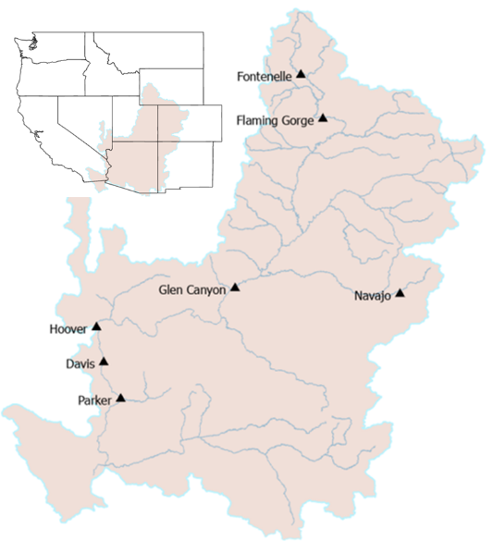
Figure 1. Location of Glen Canyon dam within the Colorado River Basin. Adapted from (Abernethy et al., 2021).
Glen Canyon Dam's hydropeaking operations provide low-cost energy to rural customers in seven Western U.S. states: Wyoming, Utah, Colorado, New Mexico, Arizona, Nevada, and Nebraska (USBR, 2023). These operations also impact riverbeds, water clarity, and ecosystem functioning (Deemer et al., 2022). Releases from the dam's cold hypolimnion maintain low downstream water temperatures, particularly in areas without tributary inflows (Cross et al., 2011). High flows entrain sediments (Vericat et al., 2020). Low flows expose aquatic life along the river's edge to desiccation (Angradi and Kubly, 1993; Kennedy et al., 2016; Young et al., 2011). Hydropeaking also erodes sandbars (Alvarez and Schmeeckle, 2013), which are vital habitats for aquatic vegetation and campsites for the Grand Canyon’s multi-million dollar rafting industry (Hoeting, 1998; USGS, 2015).
The Colorado River ecosystem in the Grand Canyon is food-limited (Cross et al., 2013, 2011; Hall Jr. et al., 2015; Kennedy et al., 2016, 2023). At the base, gross primary producers (algae) harvest solar energy. The primary producers are food for aquatic invertebrates such as stoneflies (Plecoptera), mayflies (Ephemeroptera), caddisflies, and midges. These bugs are also the food for threatened and endangered fish species like the humpback chub, razorback sucker (Xyrauchen texanus), bluehead sucker (Catostomus discobolus), Colorado pikeminnow (Ptychocheilus lucius), roundtail chub (Gila robusta), and bonytail (Gila elegans). Turbidity, canyon shading, and high river stage reduce light penetration and limit primary production. The disturbance of aquatic vegetation and drying of river edges following high flows also desiccate the eggs that bugs lay at or near the water surface (Kennedy et al., 2016).
The annual Lake Powell release is set in the fall of each year with goals to equalize storage in Lake Powell and Lake Mead, better balance storage in the two reservoirs, meet a minimum objective release of 8.23 million acre-feet per year as a delivery requirement to California, Nevada, Arizona, and Mexico, and protect Lake Powell elevation 3,525 feet —1.8 million acre-feet above the top of the penstock intakes at 3,490 feet and 5.5 million acre-feet above the low-level outlets [dead pool] at 3,370 feet (Root and Jones, 2022; USBR, 2019, 2007). The release may be updated in the spring in response to changing reservoir levels. Recent conversations for new reservoir operations post-2026 propose to lower the minimum release to 6.0 million acre-feet per year when reservoir storage is low (Buschatzke et al., 2024). Once the annual release is set, monthly release volumes are set to maximize hydropower value in high load months of January, February, March, June, July, and August. Daily hydropeaking operations are subject to constraints on minimum release, maximum release, and rate of change in releases.
Research across many locations worldwide has increasingly recognized the role of steady daily, weekly, or monthly reservoir releases in enhancing river morphology, protecting native fish populations, and restoring biotic and abiotic components of aquatic ecosystems, including aquatic invertebrates (Beechie et al., 2010; Kennedy et al., 2016; Koehn et al., 2019; Nilsson and Berggren, 2000; Palmer and Ruhi, 2019; Reid et al., 2019; Richter and Thomas, 2007; Stromberg, 2001; Stromberg et al., 2007). For example, Li et al, (2022) provided an extensive overview of ecological restoration techniques, among which steady flows were included. Evidence also suggests that steady flows enhance recreational activities by improving conditions and perceived safety (Getzner, 2015). Overall, existing research supports steady low flows for their broad ecological and recreational benefits beyond enhancing the abundance and diversity of aquatic invertebrate populations.
In the 1990s, managers started experimental releases from Glen Canyon Dam above turbine capacity for several days in some years to gain downstream ecological benefits by replicating some of the pre-dam high flood flows. These experimental releases, known as “High Flow Experiments (HFEs),” were designed to generate flood flows, mobilize sediment, and rebuild downstream sandbars (Cross et al., 2011; Robinson and Uehlinger, 2008). During months of HFEs, the monthly release volume was maintained, leading to reduced hydropower releases on days outside HFE periods. Overall, HFEs prioritized downstream ecological and recreational benefits at the expense of some hydropower value (Melis, 2011).
As part of the preferred alternative for the 2016 Glen Canyon Dam Adaptive Management Program (GCDAMP), managers also started experimental steady low releases on weekends in summer months to increase macroinvertebrate production—bug flows (USBR, 2016). These flows aimed to keep bug eggs wet, increase bug production, and diversify species. Weekends were selected for their comparatively lower energy demands and hydropeaking value than weekdays (Førsund, 2015; USBR, 2023). The volume of water saved on the weekends due to steady low bug flows was redistributed to on- and off-peak weekday releases to preserve the required monthly release volume. The flows supported the LTEMP resource goal for natural processes to “restore, to the extent practicable, ecological patterns and processes within their range of natural variability, including the natural abundance, diversity, and genetic and ecological integrity of the plant and animal species native to those ecosystems” (DOI, 2016).
Analysis of bug abundance data after experimental bug flows in summer 2018 and 2019 showed increased invertebrate production and diversity (Kennedy et al., 2023). Recent modeling work also suggested a second mechanism by which steady low flows may increase bug production (Cross et al., 2013; Deemer et al., 2022; Hall Jr. et al., 2015). In this second mechanism, steady low flows reduce downstream turbidity and lower water stage. Less turbidity and lower stage allow more sunlight to penetrate the water column and increase algae growth. More algae growth means more food for aquatic invertebrates. The same work also suggested that adding days and months of steady low flows in spring and fall may increase gross primary production (Deemer et al., 2022; Palmer and Ruhi, 2019). The modeling of flannelmouth sucker (Catostomus latipinnis) further suggested increased growth in spring and summer that has approximately the same effect as a warmer river by 1 to 2ºC (Hansen et al., 2023). Unpublished data also suggest that steady low flows may benefit aquatic invertebrate larvae at multiple life stages, including growth of small larvae in fall months and larger larvae right before they emerge in spring months (Kennedy, personal communication, 2024). Finally, current hydropeaking results in daily fluctuations in flow that are five standard deviations from the mean (Palmquist et al., 2024). More days of steady low flows can reduce deviations towards something closer to natural flow variations.
The ecological gains of the bug flow experiments came with hydropower revenue losses, estimated at $165,000 from the 2018 and $327,000 from the 2019 Bug Flow Experiments, or approximately 1% of monthly hydropower value (Ploussard and Veselka, 2019; 2020). A financial analysis of the 2018 experiment highlighted the importance of timing (i.e. months of the year) in managing costs (Ploussard and Veselka, 2019). May and June, with lower energy prices, resulted in increased total revenue, while July and August, with higher prices, saw losses. These findings suggest that adjusting the experiment’s timing could help offset hydropower losses.
While impacts on hydropeaking value are small, there is concern because the adaptive management program uses hydropower revenues to pay for bug and other experimental releases. The bug flow experiment design creates a negative feedback loop that exacerbates conflict between hydropeaking and ecosystem operations. Bug and other experimental releases mean less revenue is available to maintain project infrastructure, repay project loans to the federal treasury, and fund additional experimental flows. Additionally, hydropower managers must purchase additional energy on the open market to fulfill low-price delivery contracts during high-load periods on weekends. Those costs are only partially offset by larger releases during high load periods on weekdays to preserve monthly release targets and comply with ramp rate constraints and measurable hourly energy demands.
Next, we describe an engagement process with managers that allowed us to formulate an optimization model to quantify tradeoffs between hydropeaking value and days of steady releases that increase bug production and diversity.

Materials and Methods
3.1 Engagement
We set out to quantify tradeoffs between hydropeaking operations and experimental steady low releases that advantage bugs. We had multiple interactions with WAPA (hydropower) and Grand Canyon Monitoring and Research Center (GCMRC, ecosystem) managers and scientists. Managers explained Glen Canyon Dam's prominent role in regional low-cost energy delivery, load balancing, and spinning reserves. Managers told us to focus on hydropeaking (load following) value and ignore load balancing and spinning reserve. Our interactions guided the definition of a hydropower objective to maximize hydropeaking value. Our interactions also pointed us to the literature that supports an ecosystem objective to increase the number of consecutive days per month of steady low releases and possibly shift days of steady low releases to spring/fall months (Deemer et al., 2022; Hall Jr. et al., 2015; Hansen et al., 2023; Kennedy et al., 2023; Palmquist et al., 2024). Managers explained how bug flows are funded and pointed us to the grey literature that described operational constraints and showed that bug flow experiments increased bug production and diversity (Kennedy et al., 2023; Ploussard and Veselka, 2020, 2019; USBR, 2016). To represent sub-daily variations, managers suggested that we turn 24-hourly decisions for releases into 2 periods per day—on-peak and off-peak. This suggestion is supported by hourly release hydrographs (Figure 2), energy price data by month and hour for both 2014 and 2024 (e.g., Supplementary, Figures S1 to S3 and Tables S1 and S2), and our model development and validation (see section 4.1). In 2018 at the beginning of our project, managers shared weekday hourly contract energy prices for the months of 2014 which we used to validate the model against experimental releases observed in summer 2018 (hereafter “2014 energy prices”; Palmer, personal communication, 2019; accessible at Rind and Rosenberg, 2026). Further details, including how we estimated weekend on- and off-peak prices, are provided in the Supplemental (Text S1). Most recently, in response to a reviewer comment, we used estimated 2024 energy prices by month, day of the week, and hour of the day for the remainder of the modeling, analysis, management recommendations, and discussion. We estimated 2024 energy prices by dividing energy value data ($ nominal) by energy generation (MWh) data Interior published and used in a supplemental environmental impact statement (SEIS) in spring 2024 to allow for water releases through Glen Canyon Dam’s low-level outlets—no hydropower generation—in summer and fall of 2024 to 2026 to lower release temperature with the goal to disrupt spawning of small mouth bass (hereafter “2024 energy prices”; Yackulic et. al, 2024; Bair and Yackulic, 2024; USBR, 2024; also accessible at Rind and Rosenberg, 2026). Further details, including how we converted the hourly energy price data to estimate weekday and weekend on- and off peak prices, are provided in the Supplemental (Text S1). The distinction between 2014 and 2024 energy prices is justified because price inputs affect the economic valuation of hydropower generation but do not alter the model structure, decision variables, or constraints.
Managers also shared additional data to populate the model, such as a conversion factor that represents energy generation per 1 cfs of release [MW-hr per cfs]. The conversion factor assumed a near-constant operating head, static turbine efficiency, and static generation efficiency. All the above interactions followed best practices of collaborative modeling (Bourget et al., 2013; Langsdale et al., 2013; Palmer et al., 2013; Voinov et al., 2016)—particularly engaging parties early and identifying interests before discussing alternatives.
3.2 Hydropeaking objective
Typically, a hydropeaking objective to maximize value is a non-linear function that depends on the power generation release, the elevation difference between the reservoir water surface and tailwater, turbine efficiency, energy price, and release in relation to design efficiencies (e.g., Hochbaum, 2007; Ko et al., 1992; Tilmant et al., 2002; Yakowitz, 1982). This relationship can be linearized for reservoirs with large storage volumes such as Lake Powell where daily, weekly, or monthly release volumes draw down the reservoir water surface elevation a small amount relative to the operating head (Pérez-Díaz et al., 2010; Wang et al., 2015; Yoo, 2009). Lake Powell’s monthly elevation data (USBR, 2024b) shows minimal change relative to the tailwater elevation. This observation supports the assumption of a static reservoir elevation. We set the hydropower objective to maximize hydropeaking value, calculated by multiplying optimal turbine release with static head, turbine and generation efficiency, and energy price.
3.3 Ecosystem objective
Similarly, ecosystem objectives such as maximizing suitable habitat area and/or quality are non-linear functions that transition from unsuitable (e.g., 0) to suitable (e.g., 1) over a small range of a causal variable such as flow, water depth, or temperature (Alafifi and Rosenberg, 2020; Alminagorta et al., 2016). Discussions with GCMRC managers helped us see that primary production, bug abundance, and diversity increase proportionally to the number of consecutive days per month of steady low flows. For example, a week with steady low flow days on Saturday, Sunday, Monday, and Tuesday is preferable to Saturday, Sunday, Tuesday, and Thursday even though both week types have the same hydropeaking value.
3.4 Sub-problems
The annual Glen Canyon dam release for water supply and nested monthly release volumes for hydropower generation allowed us to break an inter-annual and annual multi-objective problem into monthly sub-problems. Each monthly sub-problem was defined by four parameters: monthly release volume, starting reservoir elevation, and contract energy prices without and with a price premium. We could change any of the four parameters to represent any month of any year.
We further broke each monthly sub-problem into two weekly release patterns. The first weekly pattern—steady low flow—had 1 to 7 days of steady low flows on consecutive days. All remaining days of the week followed daily hydropeaking operations. In the second weekly flow pattern—hydropeaking—all days followed a hydropeaking schedule. We delineated 3 day types—Sundays, Saturdays, and weekdays—by analyzing hourly flows observed at Lees Ferry gauge (station id: USGS 09380000) for months with (e.g., August 2018) and without (e.g., August 2016) weekend steady low flows (Figure 2, blue line). Each day type had corresponding on- and off-peak energy prices. The 2 weekly patterns and 3 day types allowed us to represent any number of days of steady low flows from 0 to 31 days per month. For instance, in a month with 10 steady low-flow days (e.g., August, starting on a Monday), the model places the first 4 steady days on Sundays where contract energy prices are low. The model places the next 4 days of steady flow on Saturdays, and the remaining 2 days on Mondays. In a month with 13 days of steady low flows, 4 Sundays, 4 Saturdays, 4 Mondays, and 1 Tuesday will be steady low releases while all other weekdays will be hydropeaking. In contrast, a month with zero steady low flow days means the model will decide releases for all weekends and weekdays with the flow pattern hydropeaking.
Within each day type, we divided daily releases into 2 time periods per day. The off-peak period had a single release value, low energy price, and duration of 8 hours from midnight to 8 a.m. (pLow). The on-peak period had a different release value, higher energy price, and a duration of 16 hours from 8 a.m. to midnight (pHigh; Figure 2, red line; Palmer, personal communication, 2019). On each day of steady low flow, the on- and off-peak releases had the same steady low release value. A release offset further defined the difference in flow between the release on a day of steady low flow and the next off-peak release on the next day with hydropeaking. We also explored a different number of periods per day, i.e., 3 and 4, and period lengths. We found 2018 monthly release volumes were identical and estimates of hydropower generation from 2 periods per day closely approximated actual hydropower generation. More specifically, the area under the hydrographs for the observed and modeled flow patterns were the same even though the traces do not overlay (Figure 2). We also found that 2018 monthly hydropeaking value calculated at an hourly time step using 2014 energy prices was 1.5 to 2.2% less than value modeled with 2 time periods per day (Supplementary Table S5).
3.5 Decision Variables
The annual, monthly, weekly, daily, and on- and off-peak sub-problems allowed us to model monthly operation—744 hourly decisions per month—with 12 characteristic flow decisions per month: 2 weekly flow patterns (f ε [hydropeak, steady]), 3 day types (d ε [Saturday, Sunday, and Weekday]), and 2 periods per day (p ε [pHigh, pLow]). The 2014 and 2024 hourly energy pricing data also showed 2 periods per day (Supplementary, Figures S1 to S3). Thus, our model setup allowed us to include week-to-week, day-to-day, and within day variations while keeping the computation burden low.
3.6 Objective Functions
The equation to model monthly hydropeaking value [$ per month] was:
$Hydropeaking Value=\sum_{f,d,p}{{{Price}_{d,p}× Release}_{f,d,p}}{× Duration}_{p} × N{umDays}_{f,d} × 0.03715$ (eq. 1)
Where Price_{d,p} is the energy price on day type d in period p [$ per MW-hr]; Release_{f,d,p} is the release for the flow pattern f, on day type d, in period p [cfs]; Duration_{p} is the duration of period p [hours]; NumDays_{f.d} is the number of days per month for flowpattern f and day type d; and 0.03715 is a conversion factor that represents energy generation per 1 cfs of release [MW-hr per cfs]. The conversion factor assumed a near-constant operating head, static turbine efficiency, and static generation efficiency. A collaborating WAPA manager shared the parameter value (Palmer, personal communication, 2019). This person suggested to use the same conversion value for each month.
3.7 Constraints
Seven physical constraints limit releases within infrastructure capacities. Ten managerial constraints specified the monthly release volume, limited the rate-of-change of releases during successive peak- and off-peak energy demand periods, set the number of steady low flow days per month, set releases for both periods to the low release on days of steady low flows, established relationships between low releases on different day types, and included offset releases. Additional details on the constraints are in model structure (Supplementary, Figure S7).
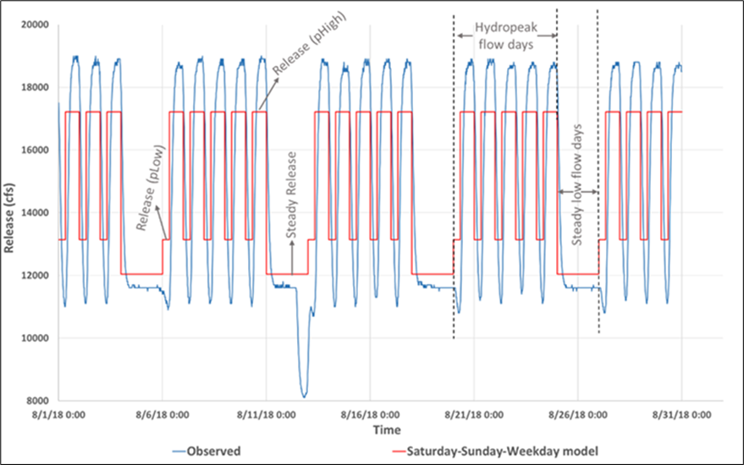
Figure 2. Comparison between hourly hydrograph observed at Lees Ferry gauge during August 2018 (blue) and the modeled hydrograph with 2 periods per day: pLow and pHigh (red).
3.8 Input Data
The principal input data comprised on- and off-peak energy prices, monthly release volume, and number of days of steady low releases per month. We specified contract energy prices without and with a price premium. These prices were used in two model variants.
Contract prices – Hydropower operators contract with power companies and rural electric utilities at long-term, fixed energy prices that vary by month, day, and hour of the day. For example, within the 2014 energy price data, August weekday off-peak prices were close to $40/MWh while on-peak prices varied from $60/MWh up to $100/MWh (Supplementary, Figure S1 and Table S1). In the 2024 energy price data, weekday off-peak prices for June to September varied from $10 to $75/MWh while weekday on-peak prices increased to $150 to $300/MWh for 1 to 2 hours per day (Supplementary, Figure S2). For both energy price data sets, we averaged energy prices for on-peak and off-peak periods across weekday and weekend daytypes (Supplementary, Figure S3 and Tables S1 and S2). This period-averaging was justified based on our model validation (see sections 3.4 and 4.1).
Market prices – WAPA purchases electricity from private companies at a market rate and sells the purchased energy at the lower contract price when demand exceeds energy generation—either due to reduced generation from bug flow releases or power generation disruptions such as from turbine or generator maintenance (Figure 3). Market prices may also fluctuate for a few hours per day or per week due to exogenous factors such as regional demand surges, grid outages, drought, surplus generation from solar and wind, or other regional energy-market fluctuations. To isolate the effect of market prices, we added a uniform $5/MWh premium to average contract energy prices across all days and pricing periods; thus, an August weekday on-peak contract price of $104.8/MWh in the 2024 energy price data set becomes $109.8/MWh. In this approach, a $5/MWh increase of average price across a 16-hour on-peak period for a single day could indicate a $40/MWh price spike for 2 hours that day or $80/MWh price spike for 1 hour that day. Similarly, a $5/MWh increase of average price across 80 on-peak weekday hours per week could indicate a $200/MWh price spike for 2 hours that week. We also tested a $30/MWh premium. This premium could indicate a price spike of $240/MWh for 2 on-peak hours per day or $1,200/MWh price spike for 2 on-peak weekday hours per week. The effects of the $30/MWh premium were not significant, as discussed in the Results section.
For scenarios with the price premium, we compared modeled releases with observed releases (Figure 3). For instance, if observed releases were higher than estimated, the resulting energy deficit was purchased at the premium price (Figure 3, red fill). Conversely, higher modeled than observed releases created an energy surplus that was sold at the premium price (Figure 3, light blue fill).
3.9 Model Formulation
The model formulation includes decision variables, objective functions, and constraints (Supplementary, Text S3). The model was implemented as a linear program in the General Algebraic Modeling System (GAMS; Hozlar, 1990). The addition of a price premium required a different model setup called the Market price model.
We introduced a Nobugflow_Rel_{d,p} (cfs) parameter for observed hydrograph, i.e., pre-bug flow releases from 2017, 2016, and 2015 (Supplementary, Fig. S4 to S6). The Market price model had two further sub-models. First, releases for zero steady low flow days (i.e., hydropeaking pattern) were priced at contract rates (Figure 3, black line). Second, optimized releases for the number of steady low flow days were compared to observed releases to determine surplus or deficit energy generation. The differential energy is priced with the market premium (Figure 3, red line/light blue and red fill). Further equations and details for the market price model are provided in the Supplementary (Text S4).
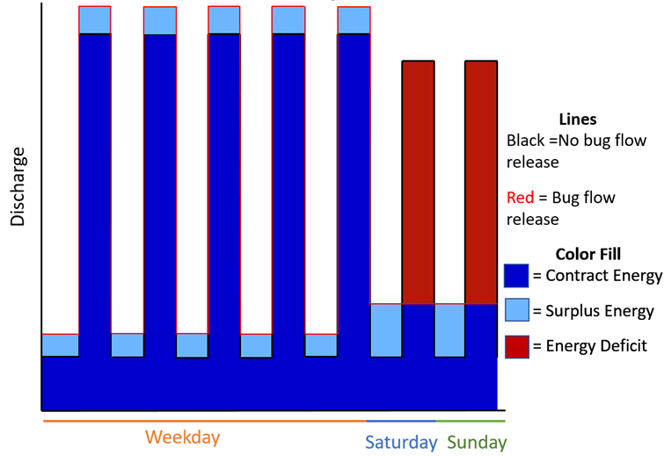
Figure 3. Conceptual model that compares energy pricing for a case with weekday hydropeaking and steady low releases on the weekend (red line) to observed releases (black line). Dark blue-filled areas indicate energy priced at the contract price. Light blue fill represents surplus energy sold at a premium price. Red fill shows energy deficits where energy is purchased at the premium price. Releases are not scaled.
3.10 Model Solution.
The bi-objective model used the constraint method to maximize hydropeaking value subject to the number of days per month of steady low releases. We varied the number of days of steady low releases from 0 to 31 days per month.
3.11 Scenarios.
The model was solved for scenarios of different monthly release volumes, energy prices, and flow offsets from Sunday to weekday low flows during March to October months when aquatic invertebrates are most productive. We varied the following parameters:
- Monthly release volume from 0.72 to 0.94 MAF that represent dry to wet conditions.
- Offset release from 0 to 1000 cfs (H0 to H1000).
- Static increase of $5/MWh above average 2024 energy prices on all days and all periods that could indicate a $40/MWh price spike for 2 hours that day, $80/MWh price spike for 1 hour that day, or a $200/MWh price spike for 2 weekday on-peak hours that week.
Results from these model runs are the basis of our subsequent analyses and management recommendations. We additionally performed 2 sensitivity analyses:
- Static increase in energy prices of $30/MWh above average 2024 prices on all days and all periods that could indicate price spikes of $240/MWh for 2 on-peak hours per day or $1,200/MWh price spikes for 2 on-peak weekday hours per week.
- Static increase in energy prices of $5/MWh above average 2014 contract prices on all days and all periods.

Results
4.1 Validation
The Contract model releases and energy generation were validated for March to October 2018 against 15-minute flow data at Lees Ferry (https://www.gcmrc.gov/‌‌‌‌‍discharge‌‌_qw_sediment/station/GCDAMP/09380000), aggregated hourly flows, and daily Glen Canyon power plant energy generation (https://www.usbr.gov/rsvrWater/HistoricalApp.​​html) (Supplementary Table S5). For example, for August 2018 the flow volume for the observed, hourly, and Saturday-Sunday-Weekday models were identical (e.g., Supplementary, Fig. S8). Energy generation varied by only 4.2% in comparison to observed energy generation (Supplementary, Table S5 and Fig. S9). The possible reasons for surplus energy generation were an assumption that the reservoir head remains constant throughout the month and an outdated conversion factor (Supplementary, Eq. S1). Validation over different months of 2018 showed that the energy generation error varied from 2.8% (July) to 9% (October; Supplementary, Table S5). Monthly hydropeaking value calculated with 2014 energy prices at an hourly time step was 1.5 to 2.2% less than value modeled with 2 time periods per day (Supplementary, Table S5). More recent 2024 energy prices affected the estimated hydropeaking value but did not materially change the optimized release pattern or energy generation. Validation runs showed no significant difference between 15-minute and hourly time steps.
4.2 Contract Model with 2024 Energy Prices
Adding steady low flow days reduced hydropeaking value in March through July and October. In August and September, each additional weekend day of steady low releases (Saturday or Sunday) increased hydropeaking value by approximately $10,000 and $2,000 per day (Figure 4; and Supplementary, Table S8). These counter-intuitive increases in both hydropeaking value and number of days of steady low releases moved tradeoff curves closer to the ideal point, representing both large hydropeaking value and more weekend days of steady low flows (Figure 4, red circle). The increase in hydropeaking value occurred because constraints Eq. S16 and S17 were relaxed during the load following pre-bug flow hydrograph. These constraints govern the relationship between on-peak releases on weekends and weekdays and activate only when steady bug flows extend beyond the weekend. Additionally, the on-peak price difference between weekend and weekday periods in August and September was smaller than in other months, where the price differential was larger (Supplementary, Table S2). Above eight days of steady low weekend flows, hydropeaking values decreased by $73,000 (August) and $76,000 (September) per day for each weekday of steady low flow added (Supplementary, Table S8). Here, constraints Eq. S7 and S8 controlled change in release between periods. Thus, the bug flow hydrograph with eight weekend steady low flow days per month maximized hydropeaking value.
The number of days of steady low reservoir releases controlled the on- and off-peak releases (Supplementary Fig. S10). Up to and including 8 steady low flow days, the model reduced off-peak releases on hydropeak days and steady low flow releases. The saved water was released during on-peak weekdays to maximize overall hydropeaking value. Above 8 days of steady low reservoir releases, the constraint that defined the allowable change in release between periods (Eq. S5) was triggered, so the model increased peak and base releases. Each additional 0.11 MAF of monthly release volume from 0.72 to 0.94 MAF representing dry to wet conditions added an extra ~$4 million in monthly hydropeaking value (Figure 4, darker blue tradeoff curves pushed right and outward). The slopes on the 0.72 MAF per month tradeoff curve differed because constraints S7 and S8 did not bind with the lower monthly flow volume. For the release scenarios of 0.72, 0.83, and 0.94 MAF per month, hydropeaking value with zero steady flow days generated the same value as at 15, 9, and 9 days of steady low flow.
An increase in offset releases slightly decreased hydropeaking value (Supplementary Fig. S11). For the remainder of this analysis, we use only the single offset release of 1000 cfs differential between off-peak weekday and steady releases (H1000).
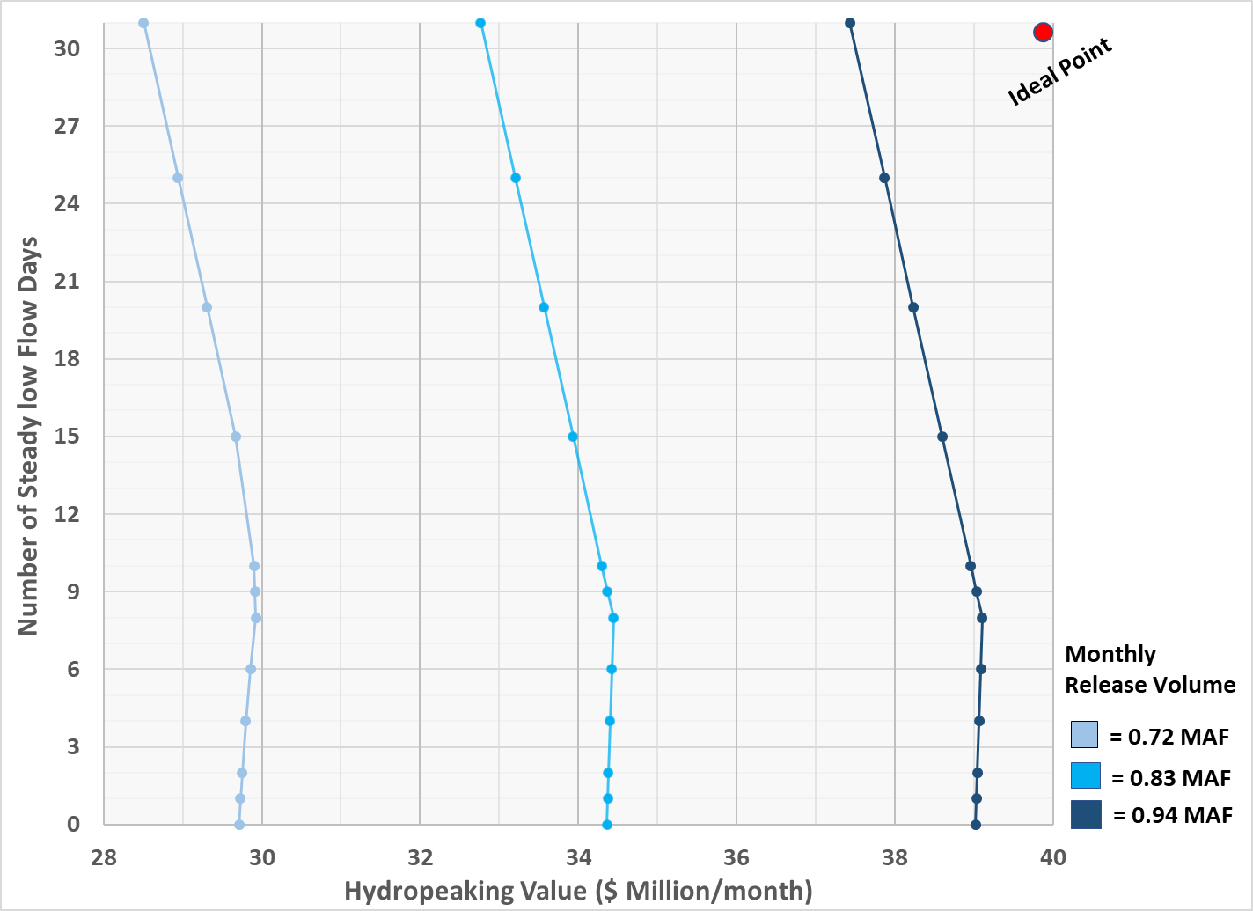
Figure 4. Tradeoffs between monthly hydropeaking value and the number of steady low flow days from the Saturday-Sunday-Weekday model during August. The model used 2024 energy prices, 1000 cfs offset release, and release volumes ranging from 0.72 MAF per month (dry conditions, light blue) to 0.94 MAF per month (wet conditions, dark blue). The ideal point in the upper-right corner (red circle) represents the best possible outcome where the hydropeaking value and environmental objectives are maximized. This outcome is not achievable because of limitations in the way bug flow experiments are currently implemented.
4.3 Market Pricing Model
Adding a $5/MWh increase above 2024 prices—representing purchase of deficit energy on the market—shifted the tradeoff curves left, reducing hydropeaking value compared to the contract model (Figure 5, red vs. blue traces). The release hydrograph remained unchanged across the scenarios because the rate-of-change constraint between on- and off-peak periods was binding. For each month modeled, each added day of steady low release reduced hydropeaking value. No breakeven point was observed.
We also evaluated price sensitivity by adding a $30/MWh premium to 2024 energy prices. This higher premium produced only a limited increase in hydropeaking value, with the tradeoff curves shifting slightly to the right relative to the baseline case (Supplementary Figure S12, red vs. blue traces).
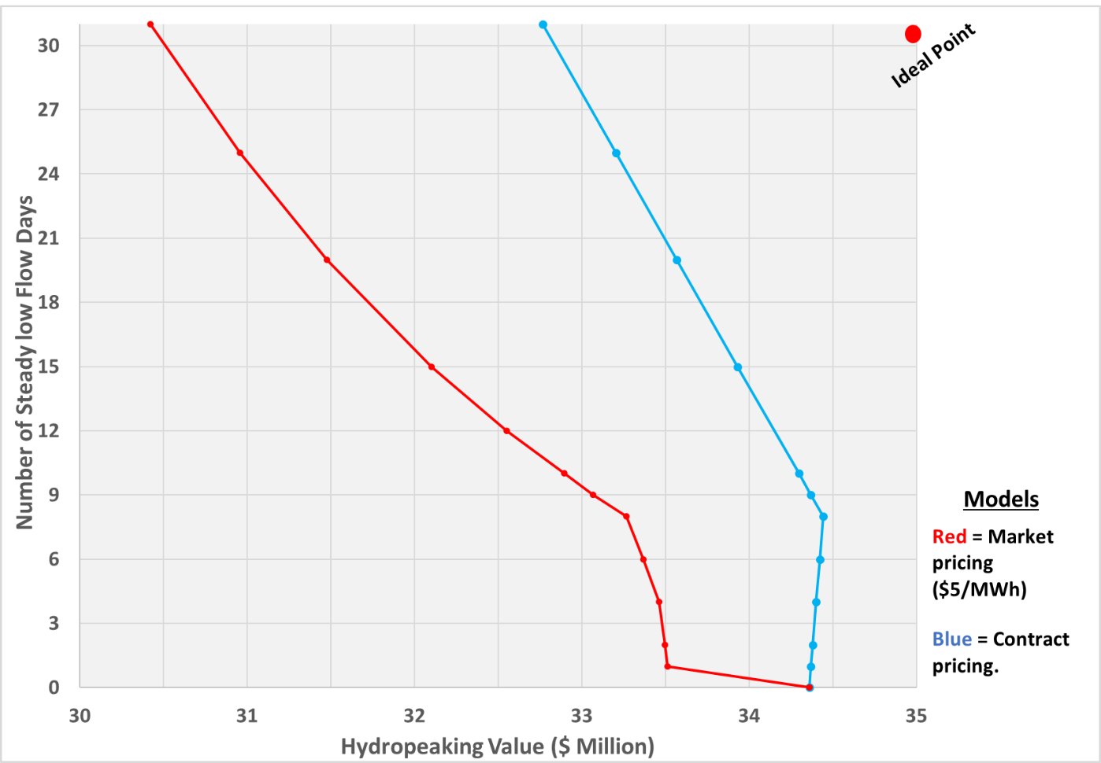
Figure 5. Comparison of tradeoffs between the prior contract model (blue) and a $5/MWh (red) increase above 2024 energy prices for a monthly 0.83 MAF release volume in August 2018 (moderate hydrology) with a 1000 cfs offset. Here, $5/MWh represents an increase above 2024 energy prices for all periods and day types.
4.4 Costs for Bug Flows with 2024 Energy Prices
Using a $5/MWh premium above 2024 energy prices, we estimated monthly hydropeaking losses for prior bug flow experiments on 4 weekends per month in May to August, 2018. These monthly losses ranged from $0.68 (June) to $1.09 million (August; Table 1). Across all months and number of days of steady low releases we tested, monthly hydropeaking losses ranged from $0.44 million (4 days of steady low releases in April) to $3.94 million (31 days of steady low releases in August Table 1). Across all number of days of steady low releases, the largest losses were in July and August, reflecting the higher value of hydropower during those peak-load months.
Table 1. Cumulative loss of hydropeaking value ($ million) per number of days of steady low releases in 2018 with 0.83 MAF release volume, H1000 (offset release), and energy prices of $5/MWh above 2024 prices. Losses are calculated relative to zero steady low-flow days (hydropeaking). Rows highlighted in blue indicate percentage losses.
Month | Value at Zero Steady days | Number of days of steady low reservoir releases
 |  | 4 | 6 | 8 | 10 | 15 | 20 | 25 | 30 | 31
March | $17.9 | $0.48 | $0.55 | $0.61 | $0.78 | $1.16 | $1.47 | $1.72 | - | $1.98
 |  | 2.7% | 3.1% | 3.4% | 4.4% | 6.5% | 8.2% | 9.6% | - | 11.1%
April | $17.4 | 0.44 | $0.52 | $0.60 | $0.79 | $1.16 | $1.42 | $1.64 | $1.84 | -
 |  | 2.5% | 3.0% | 3.4% | 4.5% | 6.7% | 8.1% | 9.4% | 10.6% | -
May | $15.6 | 0.71 | $0.80 | $0.87 | $1.07 | $1.51 | $1.87 | $2.11 | - | $2.39
 |  | 4.6% | 5.1% | 5.6% | 6.9% | 9.7% | 12.0% | 13.6% | - | 15.4%
June | $19.6 | $0.51 | $0.59 | $0.68 | $0.90 | $1.32 | $1.62 | $1.87 | $2.09 | -
 |  | 2.6% | 3.0% | 3.5% | 4.6% | 6.7% | 8.3% | 9.6% | 10.7% | -
July | $28.9 | $0.82 | $0.93 | $1.02 | $1.29 | $1.91 | $2.39 | $2.80 | - | $3.22
 |  | 2.8% | 3.2% | 3.5% | 4.5% | 6.6% | 8.3% | 9.7% | - | 11.10%
August | $34.4 | $0.89 | $0.99 | $1.09 | $1.46 | $2.25 | $2.88 | $3.40 | - | $3.94
 |  | 2.6% | 2.9% | 3.2% | 4.2% | 6.5% | 8.4% | 9.9% | - | 11.50%
September | $28.6 | $0.65 | $0.74 | $0.82 | $1.17 | $1.84 | $2.27 | $2.65 | $2.98 | -
 |  | 2.3% | 2.6% | 2.9% | 4.1% | 6.4% | 7.9% | 9.3% | 10.4% | -
October | $24.7 | $0.63 | $0.72 | $0.80 | $1.02 | $1.55 | $1.96 | $2.30 | - | $2.66
 |  | 2.5% | 2.9% | 3.2% | 4.1% | 6.3% | 7.9% | 9.3% | - | 10.80%
4.5 Sensitivity to 2014 Energy Prices
When we tested sensitivity to 2014 energy prices, we found tradeoff curves of hydropeaking value vs number of days of steady low releases had the same shape as curves for 2024 energy prices, but the x-axis intercepts (hydropeaking value with zero days of steady low releases) were shifted left or right depending on changes in weekday and weekend peak- and off-peak prices (Supplementary, Table S7). For example, in March to June, weekday on- and off-peak and weekend off-peak hydropower prices were higher in 2014 than in 2024. Thus, the x-axis intercepts of tradeoff curves shifted outward (right) to higher hydropeaking value. These shifts ranged from $0.52 million (June) to $2.83 million (May). In contrast, July and August, 2014 prices were lower for all day-types and periods than in 2024. Thus, the x-axis intercepts of tradeoff curves for July and August shifted inward (left) to lower hydropeaking value by $3.6 to $8.9 million. Using a $5/MWh premium above 2014 contract energy prices, we estimated monthly hydropeaking losses for prior bug flow experiments on 4 weekends per month in May to August, 2018. These monthly losses ranged from $80,000 (June) to $720,000 (July; Supplementary, Table S7). Across all number of days of steady low releases, the largest losses were also in July and August, reflecting the higher value of hydropower during those peak-load months. Our further analysis below focuses on results from $5/MWh premium over 2024 energy prices.

Financial Instrument to Reduce Hydropeaking-Ecosystem Conflict.
The win-lose Market pricing tradeoff curve (Figure 5, red line) highlights a conflict between hydropower producers and ecosystem managers. Under the current institutional arrangements, there is negative feedback where bug flows reduce hydropeaking value, increase costs to hydropower customers, decrease money for future bug flow experiments, and decrease money available to maintain project infrastructure and repay loans. This negative feedback loop exacerbates conflict between hydropower producers and ecosystem managers.
To reduce the conflict, we suggest that other federal and state agencies (e.g., Bureau of Reclamation, National Park Service, state fish and game agencies, etc.,) and/or environmental non-governmental organizations provide ecosystem managers a budget and greater flexibility to schedule the timing and number of days of steady low releases. The budget corresponds to the lost hydropeaking value for the current summertime weekend steady flow days. A $0.68 to $1.09 million monthly budget corresponding to a $5/MWh premium over 2024 energy prices is small compared to the ~ $20 million value of hydropeaking per summer month, ~ $200 million hydropower value per year, and recent Federal payments in excess of $200 million to fund water conservation efforts across the Colorado River basin. Managers can use the budget and their ecosystem expertise to experiment with different days of steady low releases during the summer and/or fall months and compensate hydropower producers for the costs of days of steady low releases.
Graphically, the payments convert the left-sloping, win-lose tradeoff curves (Figure 5, red line) into vertical lines of constant, stable hydropeaking value. These lines intercept the x-axis at the hydropeaking value in months with zero days of steady low releases (Table 1, Column 2, Revenue₀ [$]). Mathematically:
Hydropeaking_Value₀ = Hydropeaking_Value_{n} + Payment_for_SteadyRelease_{n} (eq. 2)
Here, Hydropeaking_Value₀ ($) and Hydropeaking_Value_{n} ($) are the modeled hydropeaking value for 0 and n days of steady releases (Figure 5, red line). Payment_for_SteadyRelease_{n} ($) is the difference in value between 0 and n days of steady low releases (Table 1).
The cumulative losses in hydropeaking value (Table 1) also suggest new experimental releases that can reduce bug flow costs—or increase the number of days of steady low releases without reducing hydropeaking value. One possibility is to shift days of steady low releases from July and August to spring/fall months when hydropeaking value is lower and bug flows are not presently implemented (e.g., March, April, September, and October). Another possibility is to shift days of steady low releases from May and June to March and/or April. Managers can then monitor whether the shifts increase gross primary production (Deemer et al., 2022; Palmer and Ruhi, 2019), help small larvae in fall months and larger larvae right before they emerge in spring months (Kennedy, personal communication, 2024), improve other ecological functions, or increase recreational benefits (Beechie et al., 2010; Getzner, 2015; Kennedy et al., 2016; Koehn et al., 2019; Nilsson and Berggren, 2000; Palmer and Ruhi, 2019; Reid et al., 2019; Richter and Thomas, 2007; Stromberg, 2001; Stromberg et al., 2007). Such shifts may also advantage native fish (Hensen et al, 2023) and reduce flow deviations closer to natural fluctuations (Lytle and Poff, 2004; Palmquist et al., 2024).
The following are example scheduling shifts:
- Eight days of steady weekend releases in June that cost $680,000 to March or April that cost $610,000 or $600,000.
- Eight steady weekend days in August that cost $1.09 million, which is comparable to the cost of eight steady weekend days plus five additional steady weekdays in March or April.
- Eight days of steady weekend releases in July cost $1.02 million, while the same budget would support 10 steady low-flow days in October, including eight weekend days and two weekdays.
Several other combinations are available (Table 1).
Results with 2014 energy prices also suggest there are financial benefits to shift days of steady low releases in July and August to spring/fall months and days in May and June to March or April (Supplementary, Table S8). Additionally, results with 2014 energy prices suggest there would be benefits to shift days of steady low releases in May and June to September or October.

Discussion
This study quantifies win-lose tradeoffs between hydropeaking value and the number of days of steady low releases that increase primary and aquatic invertebrate production. We propose an annual budget for ecosystem managers, offering them flexibility to select the number and timing of steady low-flow days and compensate hydropower producers for loss in hydropeaking value. This budget-based approach may better serve both ecosystem and hydropower interests (win-win). The proposed budget-based approach contrasts with the present institutional arrangement, where bug flow days are funded by hydropower revenue.
Ecosystem managers may use the budget to experiment with extending days of steady low releases from Glen Canyon Dam outside of summer months into spring and fall months. Managers can then monitor whether the shifts increase gross primary production (as suggested by Deemer et. al, 2022) and/or help small larvae in fall months and larger larvae right before they emerge in spring months (as suggested by Kennedy, personal communication, 2024). Managers may also monitor whether shifts reduce flow deviations closer to natural fluctuations (as suggested by Palmquist, et al, 2024) and advantage native fish (as suggested by Hensen et al, 2023).
Within the context of prior work, we discuss 10 factors that helped to reduce hydropeaking-ecosystem conflict at Glen Canyon Dam and 3 additional considerations to implement potential modifications to existing Glen Canyon Dam operations.
- Flow partition. We found wins by partitioning the seasonal and weekly flow regimes into periods of steady low flows that benefited aquatic invertebrates and periods where hydropeaking allowed producers to maximize value. Prior work beneficially partitioned flow at either the inter-annual (Dalcin et al., 2023), seasonal (Chen and Olden, 2017; Jager and Uria-Martinez, 2023), or daily (Jones, 2014) time scale.
- Bi-objectives. Two objectives defined the modeled hydropeaking-bug conflict. Tradeoffs were visualized with Cartesian plots. In contrast, Hegwood et al. (2022) reported more difficulty in finding wins as the number of objectives increases. Similarly, it is more challenging to visualize tradeoffs as the number of objectives increases (Bonham et al., 2022; Rosenberg, 2015).
- Linear relationships. As a large-volume reservoir, Lake Powell sees only a small water surface drop from Glen Canyon Dam’s monthly releases relative to the operating head. Thus, the hydropower objective to maximize value was decomposed and linearized with respect to monthly release volume, month of the year, week type, and daily on- and off-peak periods. Similarly, ecosystem managers suggested expressing the bug objective as the number of days per month of steady low releases. This number varied from 0 to 31 days per month. Linear models and relationships are easier to represent, solve, visualize, and communicate.
- Single reservoir system. The study system was for a single reservoir that was also the primary driver of the downstream flow regime. Tradeoffs and operations are more complex for geometries with multiple reservoirs in series or parallel (Lund and Guzman, 1999).
- Concave tradeoffs. Null et al., (2021) hypothesized that points of maximum concavity may represent promising compromise operations. In this work, we found 4 concave tradeoffs:
  - Existing bug flows on 8 weekend days per month with contract pricing. This point was closest to the ideal point of large hydropower value and many days of steady low flows.
  - Switching bug flows in July and August to spring/fall months can reduce the hydropeaking cost per steady low-flow day and move the tradeoff curves closer to the ideal point (Table 1; Supplementary, Table S8).
  - Similarly, switching bug flows in May and June to March or April can also reduce the hydropeaking cost per day of steady low release and move tradeoff curves closer to the ideal point.
  - The new instrument to pay hydropower producers for days of bug flows preserved hydropeaking value across all numbers of days per month of steady low flow. Tradeoff curves became perfectly convex. Each curve passed through the ideal point of maximum hydropeaking value and a maximum number of days of steady low releases.
- Stabilize revenue for hydropower producers. Providing an annual budget for ecosystem managers to compensate hydropower producers for lost hydropeaking value will stabilize hydropower revenues. If week- or day- ahead market prices increase for a day scheduled for steady releases, managers can shift bug flows later in the week or later in the month.
- Small monetary amounts. Budgets up to $1 million per summer month are small compared to the ~ $20 million value of hydropeaking per summer month, ~ $200 million hydropower value per year, and recent Federal payments in excess of $200 million to fund water conservation efforts across the Colorado River basin.
- Provide insights and flexibility rather than prescriptions. Our work suggests a new framework for experimental flows. Give ecosystem managers a budget to choose the timing and number of days of new experimental steady low releases and then pay hydropower producers for the lost value. One potential new experiment is move days of bug flows from July and August to spring/fall months to reduce costs. Another potential new experiment to reduce costs is move days of bug flows from May and June to March or April. Flexibility allows ecosystem managers to use emerging data and their expert judgment to pick the number and timing of days of steady low flows rather than contesting new operations with hydropower managers. Flexibility also avoids the need for researchers to define and include ecosystem preferences in a model.
- Repeated engagement and collaboration with managers. Ecosystem managers and hydropower operators defined the bi-objectives for hydropeaking value and the number of days of steady low flows in collaboration with researchers. We also regularly engaged with managers to acquire data, share preliminary results, discuss results, and put results in context. For example, engagement helped us understand current institutional arrangements such as offset releases, the difference between contract and market energy prices, and how experimental bug flows are funded. These institutional arrangements are not described in the peer-reviewed literature. As an example of this success, our collaborating hydropower and ecosystem managers invited us to present this work to the technical work group for the GCDAMP in April 2023 (Rind and Rosenberg, 2026). Technical work group members wanted to further investigate our findings and insights. These insights can inform the design and implementation of new, more expensive experimental releases (since August 2024) through Lake Powell’s low level river outlets that bypass hydropower generation and have the goal to lower downstream temperature and disadvantage small-mouth bass. Our engagement followed many best practices for collaborative and participatory modeling (Langsdale et al., 2013; Voinov et al., 2016). In contrast, prior ecosystem optimization efforts did not mention engagement with or take up by managers (Horne et al., 2016).
- Situated work in institutional context, enabling legislation, and policy environment. Our engagement with ecosystem and hydropower managers also helped us identify how an ecosystem budget can correct an existing institutional arrangement and negative feedback loop where bug flows reduce hydropeaking value. The GCDAMP technical workgroup also provide a regulatory and policy environment where new operations can be discussed, implemented, and tested. In contrast, many similar efforts fail because there is not a larger environment to implement researcher recommendations (Owusu et al., 2022).
There are additional considerations to implement more flexible operations:
- The 2016 Record of Decision (DOI 2016) states that bug flows will occur on weekends in May through August with no discussion of how to address corresponding decreases in hydropower revenue. At the same time, the Secretary of the Interior retains the (i) ability to adjust the duration and other characteristics of experimental bug flows based on the results of initial experiments, and (ii) sole discretion to decide how best to accomplish operations and experiments in any given year. Given the conflict surrounding nearly all aspects of Colorado River management, Interior may decide to issue a new supplemental EIS that allows for bug flows in spring/summer. Interior issued a similar supplemental EIS in spring 2024 to allow for water releases through Glen Canyon Dam’s low-level outlets—no hydropower generation—in summer and fall of 2024 to 2026 to lower release temperature with the goal to disrupt spawning of small mouth bass.
- We acknowledge that future energy prices may change the magnitude of reported hydropeaking values, lost value per day of steady low releases, and ecosystem budget.
- The energy generation formula we used does not capture a declining Lake Powell water levels across multiple years. Drawdown lowers energy head, efficiency, generation, and hydropeaking value (e.g., Supplementary Table S6). As energy generation decreases, we expect tradeoff curves for hydropeaking value and days of steady releases will shift left to lower value. We also expect the tradeoff curves to show larger lost value per day of added steady low release.
We recommend the following next steps:
- When planning a new round of bug flow experiments, use the most recent energy prices.
- Further validate results—use the proprietary GTMax SL model that hydropower producers use to schedule hydropower operations.
- Further engage people at federal agencies such as Reclamation and National Park Service and state fish and game agencies.
- Apply the proposed financial instrument to other reservoir releases that benefit ecosystems and reduce hydropower value. These releases may mobilize sediment, build sand bars, or disadvantage non-native fish (USBR, 2016). These experimental releases are more controversial because the impacts on hydropower are larger. For example, these experiments include releases through the low-level river outlets that do not generate hydropower for a few days in a season (sediment) or every off-peak of every day for late summer and fall months (disrupt small mouth bass spawning). Thus, giving ecosystem managers flexibility to schedule releases to mobilize sediment or disrupt spawning by invasive fish will require larger budgets by a factor of 20 or more relative to bug experiments.

Conclusions
Steady low reservoir releases allow downstream aquatic invertebrates to lay and hatch more eggs. These releases also lower turbidity and water stage, which increases algal production—an important food for bugs. Steady low releases also reduce hydropeaking value, increase costs to hydropower customers, lower funds to maintain project infrastructure, delay loan repayment, and exacerbate conflict between hydropower and ecosystem managers. We formulated and solved a bi-objective optimization model to quantify tradeoffs between hydropeaking value and the number of days of steady low releases. We validated monthly energy generation and value in the months of March to October, 2018. We ran scenarios for different monthly release volumes, offset releases, and energy prices for March through October.
We estimated that the 2018 experiment with steady low-flow releases for eight weekend days per summer month reduced monthly hydropeaking value by $0.68 to $1.09 million across May-August. To reduce hydropeaking-ecosystem conflict, we suggested to give ecosystem managers a budget to choose the timing and number of days of new experimental steady low flows and then pay hydropower producers for the lost value. One potential experiment—also suggested by recent ecological monitoring and modeling—is to shift days of steady low releases from July or August to spring/fall months. Another potential experiment is to shift days of steady low releases from May or June to March or April. Our results were insensitive to price premiums up to $30/MWh that could indicate price spikes of $240/MWh for 2 on-peak hours per day or $1,200/MWh price spikes for 2 on-peak weekday hours per week.
We achieved the above results because we engaged with hydropower and ecosystem managers through the duration of our research project. We believe our work can be improved by including inputs from the proprietary GTMax SL model used by hydropower producers. We also believe that a financial instrument that gives ecosystem managers a budget to schedule steady low flows can be extended to other reservoir releases that reduce hydropower value such as mobilize sediment, build sand bars, and/or disadvantage non-native, invasive fish.

Data Availability Statement
The data, models, code, and directions to use are available in a Hydroshare repository (Rind and Rosenberg, 2026). Bhupinderjeet Singh and Philip Moffatt at Washington State University, USA downloaded the materials and reproduced all figures and tables with results for 2014 energy prices. Caitlyn Andrus (Utah State University) downloaded the materials and reproduced figures and tables with results for 2024 energy prices.

Declaration of Competing Interest
The authors declare that they have no known competing financial interests or personal relationships that could have appeared to influence the work reported in this paper.

Acknowledgments
The Higher Education Commission of Pakistan, the Future of the Colorado River Project, and the Utah Water Research Laboratory provided financial support. The funding sources had no involvement in the study design, data collection, analysis, interpretation, manuscript writing, or the decision to submit it for publication. Stanley Clayton Palmer (now deceased), Craig Ellsworth, Theodore Kennedy, and Jack Schmidt contributed data and/or discussion that helped identify tradeoffs between hydropeaking value and days of steady low flows.

References
Abernethy, E.F., Muehlbauer, J.D., Kennedy, T.A., Tonkin, J.D., Van Driesche, R., Lytle, D.A., 2021. Hydropeaking intensity and dam proximity limit aquatic invertebrate diversity in the Colorado River Basin. Ecosphere 12, e03559. https://doi.org/10.1002/ecs2.3559
Alafifi, A.H., Rosenberg, D.E., 2020. Systems modeling to improve river, riparian, and wetland habitat quality and area. Environ. Model. Softw. 126, 104643. https://doi.org/10.1016/j.envsoft.2020.104643
Alminagorta, O., Rosenberg, D.E., Kettenring, K.M., 2016. Systems modeling to improve the hydro-ecological performance of diked wetlands. WATER Resour. Res. 52, 7070–7085. https://doi.org/10.1002/2015WR018105
Alvarez, L.V., Schmeeckle, M.W., 2013. Erosion of River Sandbars by Diurnal Stage Fluctuations in the Colorado River in the Marble and Grand Canyons: Full-Scale Laboratory Experiments. River Res. Appl. 29, 839–854. https://doi.org/10.1002/rra.2576
Angradi, T.R., Kubly, D.M., 1993. Effects of atmospheric exposure on chlorophyll a, biomass and productivity of the epilithon of a tailwater river. Regul. Rivers Res. Manag. 8, 345–358. https://doi.org/10.1002/rrr.3450080405
Beechie, T.J., Sear, D.A., Olden, J.D., Pess, G.R., Buffington, J.M., Moir, H., Roni, P., Pollock, M.M., 2010. Process-based Principles for Restoring River Ecosystems. BioScience 60, 209–222. https://doi.org/10.1525/bio.2010.60.3.7
Bonham, N., Kasprzyk, J., Zagona, E., 2022. post-MORDM: Mapping policies to synthesize optimization and robustness results for decision-maker compromise. Environ. Model. Softw. 157, 105491. https://doi.org/10.1016/j.envsoft.2022.105491
Bourget, E.C., Langsdale, S.M., van den Belt, M., 2013. Featured Collection Introduction: Collaborative Modeling for Decision Support as a Tool to Implement IWRM. JAWRA J. Am. Water Resour. Assoc. 49, 605–608. https://doi.org/10.1111/jawr.12071
Bunn, S.E., Arthington, A.H., 2002. Basic Principles and Ecological Consequences of Altered Flow Regimes for Aquatic Biodiversity. Environ. Manage. 30, 492–507. https://doi.org/10.1007/s00267-002-2737-0
Buschatzke, T., Hamby, J.B., Entsminger, J., 2024. Lower Basin Alternative for the Post-2026 Coordinated Operation of the Colorado River Basin.
Chen, W., Olden, J.D., 2017. Designing flows to resolve human and environmental water needs in a dam-regulated river. Nat. Commun. 8, 2158. https://doi.org/10.1038/s41467-017-02226-4
CRB California, 2023. MONTHLY REPORT TO THE COLORADO RIVER BOARD OF CALIFORNIA.
Cross, W.F., Baxter, C.V., Donner, K.C., Rosi-Marshall, E.J., Kennedy, T.A., Hall Jr, R.O., Kelly, H.A.W., Rogers, R.S., 2011. Ecosystem ecology meets adaptive management: food web response to a controlled flood on the Colorado River, Glen Canyon. Ecol. Appl. 21, 2016–2033. https://doi.org/10.1890/10-1719.1
Cross, W.F., Baxter, C.V., Rosi-Marshall, E.J., Hall Jr., R.O., Kennedy, T.A., Donner, K.C., Wellard Kelly, H.A., Seegert, S.E.Z., Behn, K.E., Yard, M.D., 2013. Food-web dynamics in a large river discontinuum. Ecol. Monogr. 83, 311–337. https://doi.org/10.1890/12-1727.1
Dalcin, A.P., Marques, G.F., Tilmant, A., Olivares, M., 2023. Dynamic Adaptive Environmental Flows (DAE-Flows) to Reconcile Long-Term Ecosystem Demands With Hydropower Objectives. Water Resour. Res. 59, e2022WR034064. https://doi.org/10.1029/2022WR034064
Deemer, B.R., Yackulic, C.B., Hall, R.O., Jr, Dodrill, M.J., Kennedy, T.A., Muehlbauer, J.D., Topping, D.J., Voichick, N., Yard, M.D., 2022. Experimental reductions in subdaily flow fluctuations increased gross primary productivity for 425 river kilometers downstream. PNAS Nexus 1, pgac094. https://doi.org/10.1093/pnasnexus/pgac094
DOI, 2016. Glen Canyon Dam Long-Term Experimental and Management Plan Final Environmental Impact Statement.
Førsund, F.R., 2015. Hydropower Economics, International Series in Operations Research & Management Science. Springer US, Boston, MA. https://doi.org/10.1007/978-1-4899-7519-5
Getzner, M., 2015. Importance of Free-Flowing Rivers for Recreation: Case Study of the River Mur in Styria, Austria. J. Water Resour. Plan. Manag. J. Water Resour. Plan. Manag. 141, 04014050. https://doi.org/10.1061/(ASCE)WR.1943-5452.0000442
Gloss, S.P., Lovich, J.E., Melis, T.S., 2005. The State of the Colorado River Ecosystem in Grand Canyon, USGS Circular 1282.
Hall Jr., R.O., Yackulic, C.B., Kennedy, T.A., Yard, M.D., Rosi-Marshall, E.J., Voichick, N., Behn, K.E., 2015. Turbidity, light, temperature, and hydropeaking control primary productivity in the Colorado River, Grand Canyon. Limnol. Oceanogr. 60, 512–526. https://doi.org/10.1002/lno.10031
Hansen, L.E., Yackulic, C.B., Dickson, B.G., Deemer, B.R., Best, R.J., 2023. Linking ecosystem processes to consumer growth rates: gross primary productivity as a driver of freshwater fish somatic growth in a resource-limited river. Can. J. Fish. Aquat. Sci. 80, 1456–1469. https://doi.org/10.1139/cjfas-2022-0229
Hauer, C., Wagner, B., Aigner, J., Holzapfel, P., Flödl, P., Liedermann, M., Tritthart, M., Sindelar, C., Pulg, U., Klösch, M., Haimann, M., Donnum, B.O., Stickler, M., Habersack, H., 2018. State of the art, shortcomings and future challenges for a sustainable sediment management in hydropower: A review. Renew. Sustain. Energy Rev. 98, 40–55. https://doi.org/10.1016/j.rser.2018.08.031
Hegwood, M., Langendorf, R.E., Burgess, M.G., 2022. Why win-wins are rare in complex environmental management. Nat. Sustain. 5, 674–680. https://doi.org/10.1038/s41893-022-00866-z
Hochbaum, D.S., 2007. Complexity and algorithms for nonlinear optimization problems. Ann. Oper. Res. 153, 257–296. https://doi.org/10.1007/s10479-007-0172-6
Horne, A., Szemis, J.M., Kaur, S., Webb, J.A., Stewardson, M.J., Costa, A., Boland, N., 2016. Optimization tools for environmental water decisions: A review of strengths, weaknesses, and opportunities to improve adoption. Environ. Model. Softw. 84, 326–338. https://doi.org/10.1016/j.envsoft.2016.06.028
Hozlar, E., 1990. Gams-General Algebraic Modeling System for Mathematical-Modeling. Ekonomicko-Matematicky Obzor 26, 96–99.
Jager, H.I., Smith, B.T., 2008. Sustainable reservoir operation: can we generate hydropower and preserve ecosystem values? River Res. Appl. 24, 340–352. https://doi.org/doi:10.1002/rra.1069
Jager, H.I., Uria-Martinez, R., 2023. Finding middle ground: Flow regimes designed for salmon and energy value. Water Biol. Secur. 2, 100183. https://doi.org/10.1016/j.watbs.2023.100183
Jones, N.E., 2014. The Dual Nature of Hydropeaking Rivers: Is Ecopeaking Possible? River Res. Appl. 30, 521–526. https://doi.org/10.1002/rra.2653
Kennedy, T.A., Muehlbauer, J.D., Yackulic, C.B., Lytle, D.A., Miller, S.W., Dibble, K.L., Kortenhoeven, E.W., Metcalfe, A.N., Baxter, C.V., 2016. Flow Management for Hydropower Extirpates Aquatic Insects, Undermining River Food Webs. BIOSCIENCE 66, 561–575. https://doi.org/10.1093/biosci/biw059
Kennedy, T.R., Muehlbauer, J., Metcalfe, A., Deemer, B., Ford, M., Szydlo, C., Behn, K., Yackulic, C., 2023. Experimental Bug Flows Enhance Natural Processes That Sustain The Colorado River Ecosystem.
Ko, S.-K., Fontane, D.G., Labadie, J.W., 1992. Multiobjectwe Optimization of Reservoir Systems Operation1. JAWRA J. Am. Water Resour. Assoc. 28, 111–127. https://doi.org/10.1111/j.1752-1688.1992.tb03158.x
Koehn, J.D., Balcombe, S.R., Zampatti, B.P., 2019. Fish and flow management in the Murray–Darling Basin: Directions for research. Ecol. Manag. Restor. 20, 142–150. https://doi.org/10.1111/emr.12358
Kraft, M., Rosenberg, D.E., Null, S.E., 2019. Prioritizing Stream Barrier Removal to Maximize Connected Aquatic Habitat and Minimize Water Scarcity. JAWRA J. Am. Water Resour. Assoc. 55, 382–400. https://doi.org/10.1111/1752-1688.12718
Langsdale, S., Beall, A., Bourget, E., Hagen, E., Kudlas, S., Palmer, R., Tate, D., Werick, W., 2013. Collaborative Modeling for Decision Support in Water Resources: Principles and Best Practices. JAWRA J. Am. Water Resour. Assoc. 49, 629–638. https://doi.org/10.1111/jawr.12065
Li, P., Li, D., Sun, X., Chu, Z., Xia, T., Zheng, B., 2022. Application of Ecological Restoration Technologies for the Improvement of Biodiversity and Ecosystem in the River. Water 14, 1402. https://doi.org/10.3390/w14091402
Liermann, C.R., Nilsson, C., Robertson, J., Ng, R.Y., 2012. Implications of Dam Obstruction for Global Freshwater Fish Diversity. BioScience 62, 539–548. https://doi.org/10.1525/bio.2012.62.6.5
LTEMP Team, 2022. Final Recommendation to Implement Experimental Macroinvertebrate Production Flow Releases (“Bug Flows”) at Glen Canyon Dam in Water Year 2022.
Lund, J.R., Guzman, J., 1999. Derived Operating Rules for Reservoirs in Series or in Parallel. J. Water Resour. Plan. Manag. 125, 143–153. https://doi.org/10.1061/(ASCE)0733-9496(1999)125:3(143)
Lytle, D.A., Poff, N.L., 2004. Adaptation to natural flow regimes. Trends Ecol. Evol. 19, 94–100. https://doi.org/10.1016/j.tree.2003.10.002
Melis, T.S., 2011. Effects of Three High-Flow Experiments on the Colorado River Ecosystem Downstream from Glen Canyon Dam, Arizona (No. U.S. Geological Survey Circular 1366). U.S. Geological Survey.
Moog, O., 1993. Quantification of daily peak hydropower effects on aquatic fauna and management to minimize environmental impacts. Regul. Rivers Res. Manag. 8, 5–14. https://doi.org/10.1002/rrr.3450080105
Nilsson, C., Berggren, K., 2000. Alterations of Riparian Ecosystems Caused by River Regulation: Dam operations have caused global-scale ecological changes in riparian ecosystems. How to protect river environments and human needs of rivers remains one of the most important questions of our time. BioScience 50, 783–792. https://doi.org/10.1641/0006-3568(2000)050%5B0783:AORECB%5D2.0.CO;2
Null, S.E., Olivares, M.A., Cordera, F., Lund, J.R., 2021. Pareto Optimality and Compromise for Environmental Water Management. Water Resour. Res. 57, e2020WR028296. https://doi.org/10.1029/2020WR028296
Owusu, A., Mul, M., van der Zaag, P., Slinger, J., 2022. May the Odds Be in Your Favor: Why Many Attempts to Reoperate Dams for the Environment Stall. J. WATER Resour. Plan. Manag. 148, 04022009. https://doi.org/10.1061/(ASCE)WR.1943-5452.0001521
Palmer, M., Ruhi, A., 2019. Linkages between flow regime, biota, and ecosystem processes: Implications for river restoration. Science 365, eaaw2087. https://doi.org/10.1126/science.aaw2087
Palmer, R.N., Cardwell, H.E., Lorie, M.A., Werick, W., 2013. Disciplined Planning, Structured Participation, and Collaborative Modeling — Applying Shared Vision Planning to Water Resources. JAWRA J. Am. Water Resour. Assoc. 49, 614–628. https://doi.org/10.1111/jawr.12067
Palmquist, E.C., Deemer, B.R., Metcalfe, A.N., Kennedy, T.A., Bair, L.S., Fairley, H.C., Grams, P.E., Sankey, J.B., Yackulic, C.B., 2024. eZ flow metrics: Using z-scores to estimate deviations from natural flow in the Colorado River below Glen Canyon Dam. River Res. Appl. https://doi.org/10.1002/rra.4360
Pérez-Díaz, J.I., Wilhelmi, J.R., Arévalo, L.A., 2010. Optimal short-term operation schedule of a hydropower plant in a competitive electricity market. Energy Convers. Manag. 51, 2955–2966. https://doi.org/10.1016/j.enconman.2010.06.038
Ploussard, Q., Veselka, T.D., 2020. Financial Analysis of the 2019 Glen Canyon Dam Bug Flow Experiment (No. ANL-20/81). Argonne National Lab. (ANL), Argonne, IL (United States). https://doi.org/10.2172/1734861
Ploussard, Q., Veselka, T.D., 2019. Financial Analysis of the 2018 Glen Canyon Dam Bug Flow Experiment (No. ANL-19/19, 1526634). https://doi.org/10.2172/1526634
Poff, N.L., Olden, J.D., Merritt, D.M., Pepin, D.M., 2007. Homogenization of regional river dynamics by dams and global biodiversity implications. Proc. Natl. Acad. Sci. 104, 5732–5737. https://doi.org/10.1073/pnas.0609812104
Poff, N.L., Zimmerman, J.K.H., 2010. Ecological responses to altered flow regimes: a literature review to inform the science and management of environmental flows. Freshw. Biol. 55, 194–205. https://doi.org/10.1111/j.1365-2427.2009.02272.x
Porse, E.C., Sandoval-Solis, S., Lane, B.A., 2015. Integrating Environmental Flows into Multi-Objective Reservoir Management for a Transboundary, Water-Scarce River Basin: Rio Grande/Bravo. Water Resour. Manag. 29, 2471–2484. https://doi.org/10.1007/s11269-015-0952-8
Reid, A.J., Carlson, A.K., Creed, I.F., Eliason, E.J., Gell, P.A., Johnson, P.T.J., Kidd, K.A., MacCormack, T.J., Olden, J.D., Ormerod, S.J., Smol, J.P., Taylor, W.W., Tockner, K., Vermaire, J.C., Dudgeon, D., Cooke, S.J., 2019. Emerging threats and persistent conservation challenges for freshwater biodiversity. Biol. Rev. 94, 849–873. https://doi.org/10.1111/brv.12480
Rheinheimer, D.E., Null, S.E., Lund, J.R., 2015. Optimizing Selective Withdrawal from Reservoirs to Manage Downstream Temperatures with Climate Warming. J. Water Resour. Plan. Manag. 141, 04014063. https://doi.org/10.1061/(ASCE)WR.1943-5452.0000447
Richter, B.D., Thomas, G.A., 2007. Restoring Environmental Flows by Modifying Dam Operations. Ecol. Soc. 12.
Rind, M., Rosenberg, D., 2026. Bugs Pay for Days of Steady Reservoir Releases to Reduce Hydropeaking-Ecosystem Conflict. https://github.com/moazzamalirind/BugFlowExperiment_Analysis2026
Robinson, C.T., Uehlinger, U., 2008. Experimental Floods Cause Ecosystem Regime Shift in a Regulated River. Ecol. Appl. 18, 511–526. https://doi.org/10.1890/07-0886.1
Root, J.C., Jones, D., 2022. Elevation-area-capacity relationships of Lake Powell in 2018 and estimated loss of storage capacity since 1963 (No. 2022–5017), Scientific Investigations Report. U.S. Geological Survey. https://doi.org/10.3133/sir20225017
Rosenberg, D.E., 2015. Blended near-optimal alternative generation, visualization, and interaction for water resources decision making. Water Resour. Res. 51, 2047–2063. https://doi.org/10.1002/2013WR014667
Stromberg, J.C., 2001. Restoration of riparian vegetation in the south-western United States: importance of flow regimes and fluvial dynamism. J. Arid Environ. 49, 17–34. https://doi.org/10.1006/jare.2001.0833
Stromberg, J.C., Beauchamp, V.B., Dixon, M.D., Lite, S.J., Paradzick, C., 2007. Importance of low-flow and high-flow characteristics to restoration of riparian vegetation along rivers in arid south-western United States. Freshw. Biol. 52, 651–679. https://doi.org/10.1111/j.1365-2427.2006.01713.x
Tilmant, A., Vanclooster, M., Duckstein, L., Persoons, E., 2002. Comparison of Fuzzy and Nonfuzzy Optimal Reservoir Operating Policies. J. Water Resour. Plan. Manag. 128, 390–398. https://doi.org/10.1061/(ASCE)0733-9496(2002)128:6(390)
Topping, D.J., Schmidt, J.C., Vierra Jr., L.E., 2003. Computation and analysis of the instantaneous-discharge record for the Colorado River at Lees Ferry, Arizona : May 8, 1921, through September 30, 2000 (USGS Numbered Series No. 1677), Computation and analysis of the instantaneous-discharge record for the Colorado River at Lees Ferry, Arizona : May 8, 1921, through September 30, 2000, Professional Paper. https://doi.org/10.3133/pp1677
Unterhitzenberger, C., Wilson, H., James Bryde, D., Rost, M., Joby, R., 2021. The stakeholder challenge: dealing with challenging situations involving stakeholders. Prod. Plan. Control 32, 926–941. https://doi.org/10.1080/09537287.2020.1776907
USBR, 2024a. Glen Canyon Dam Long-Term Experimental and Management Plan | Upper Colorado Basin | Bureau of Reclamation [WWW Document]. URL https://www.usbr.gov/uc/progact/amp/ltemp.html (accessed 8.8.24).
USBR, 2024b. Lake Powell and Lake Mead: End of Month Elevation charts.
USBR, 2023. Glen Canyon Dam | Upper Colorado Region | Bureau of Reclamation [WWW Document]. Glen Canyon Unit. URL https://www.usbr.gov/uc/rm/crsp/gc/ (accessed 12.9.23).
USBR, 2019. Drought Contingency Plans | Bureau of Reclamation [WWW Document]. URL https://www.usbr.gov/ColoradoRiverBasin/dcp/index.html (accessed 9.28.24).
USBR, 2016. LTEMP 2016 [WWW Document]. Integrating LTEMP GCDAMP Process. URL https://www.usbr.gov/uc/progact/amp/twg/2016-10-18-twg-meeting/Attach_08.pdf (accessed 12.9.23).
USBR, 2007. Record of Decision: Colorado River Interim Guidelines for Lower Basin Shortages and Coordinated Operations for Lakes Powell and Mead.
Vericat, D., Ville, F., Palau-Ibars, A., Batalla, R.J., 2020. Effects of Hydropeaking on Bed Mobility: Evidence from a Pyrenean River. Water 12, 178. https://doi.org/10.3390/w12010178
Voinov, A., Kolagani, N., McCall, M.K., Glynn, P.D., Kragt, M.E., Ostermann, F.O., Pierce, S.A., Ramu, P., 2016. Modelling with stakeholders – Next generation. Environ. Model. Softw. 77, 196–220. https://doi.org/10.1016/j.envsoft.2015.11.016
Vörösmarty, C.J., McIntyre, P.B., Gessner, M.O., Dudgeon, D., Prusevich, A., Green, P., Glidden, S., Bunn, S.E., Sullivan, C.A., Liermann, C.R., Davies, P.M., 2010. Global threats to human water security and river biodiversity. Nature 467, 555–561. https://doi.org/10.1038/nature09440
Wang, H., Brill, E.D., Ranjithan, R.S., Sankarasubramanian, A., 2015. A framework for incorporating ecological releases in single reservoir operation. Adv. Water Resour. 78, 9–21. https://doi.org/10.1016/j.advwatres.2015.01.006
Wheeler, K.G., Hall, J.W., Abdo, G.M., Dadson, S.J., Kasprzyk, J.R., Smith, R., Zagona, E.A., 2018. Exploring Cooperative Transboundary River Management Strategies for the Eastern Nile Basin. Water Resour. Res. 54, 9224–9254. https://doi.org/10.1029/2017WR022149
Wild, T.B., Reed, P.M., Loucks, D.P., Mallen-Cooper, M., Jensen, E.D., 2019. Balancing Hydropower Development and Ecological Impacts in the Mekong: Tradeoffs for Sambor Mega Dam. J. Water Resour. Plan. Manag. 145, 05018019. https://doi.org/10.1061/(ASCE)WR.1943-5452.0001036
Winemiller, K.O., McIntyre, P.B., Castello, L., Fluet-Chouinard, E., Giarrizzo, T., Nam, S., Baird, I.G., Darwall, W., Lujan, N.K., Harrison, I., Stiassny, M.L.J., Silvano, R.A.M., Fitzgerald, D.B., Pelicice, F.M., Agostinho, A.A., Gomes, L.C., Albert, J.S., Baran, E., Petrere, M., Zarfl, C., Mulligan, M., Sullivan, J.P., Arantes, C.C., Sousa, L.M., Koning, A.A., Hoeinghaus, D.J., Sabaj, M., Lundberg, J.G., Armbruster, J., Thieme, M.L., Petry, P., Zuanon, J., Vilara, G.T., Snoeks, J., Ou, C., Rainboth, W., Pavanelli, C.S., Akama, A., Soesbergen, A. van, Sáenz, L., 2016. Balancing hydropower and biodiversity in the Amazon, Congo, and Mekong. Science 351, 128–129. https://doi.org/10.1126/science.aac7082
Wright, S.A., Anderson, C.R., Voichick, N., 2009. A simplified water temperature model for the Colorado River below Glen Canyon Dam. River Res. Appl. 25, 675–686. https://doi.org/https://doi.org/10.1002/rra.1179
Yakowitz, S., 1982. Dynamic programming applications in water resources. Water Resour. Res. 18, 673–696. https://doi.org/10.1029/WR018i004p00673
Yoo, J.-H., 2009. Maximization of hydropower generation through the application of a linear programming model. J. Hydrol. 376, 182–187. https://doi.org/10.1016/j.jhydrol.2009.07.026
Young, P.S., Cech, J.J., Thompson, L.C., 2011. Hydropower-related pulsed-flow impacts on stream fishes: a brief review, conceptual model, knowledge gaps, and research needs. Rev. Fish Biol. Fish. 21, 713–731. https://doi.org/10.1007/s11160-011-9211-0

